**Ch-Square Test for Association of Categorical Variables**

The table below presents voter reactions to a new property tax plan according to party affiliation.

From these data, construct a table of the expected frequencies based on the assumption that there is no relationship between party affiliation and reaction to the tax plan.

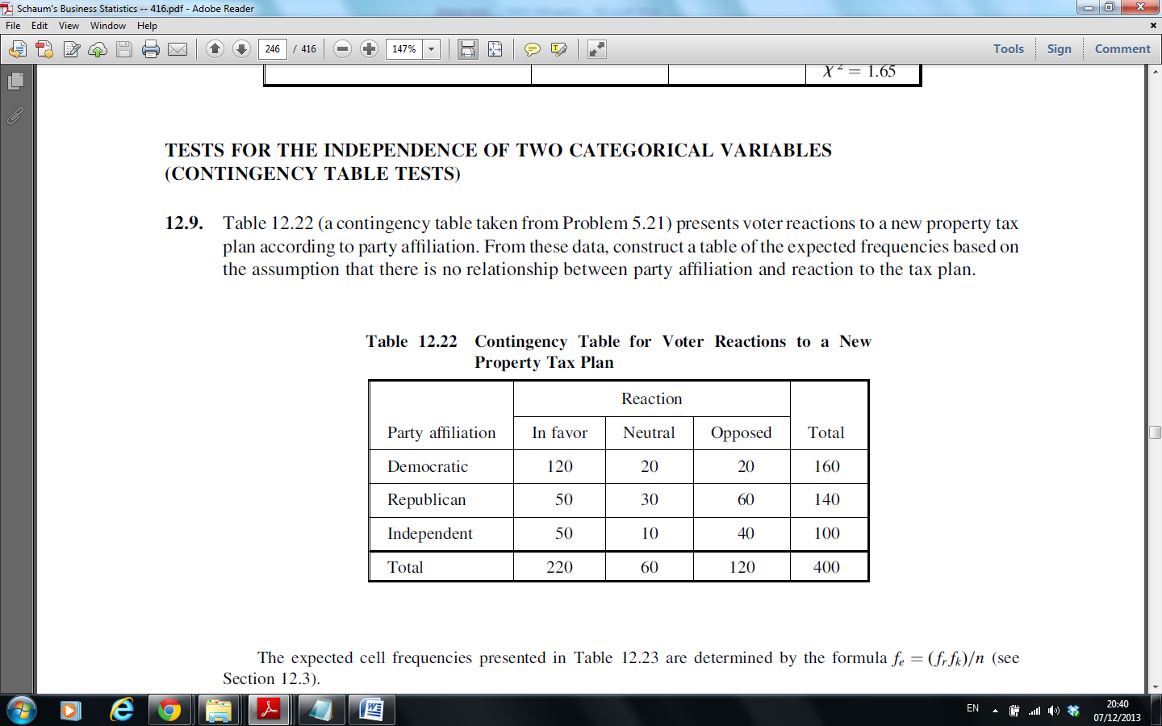

***Null and Alternative Hypotheses***

H0: Party affiliation and voter reaction are independent

(there is no relationship).

H1: Party affiliation and voter reaction are not independent.

(there is a relationship)

***Table of Expected Frequencies for the Observed Frequencies***

